
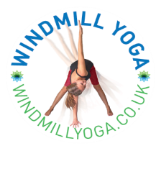

Yoga at Wheatfields Primary School
Spring Term 2026 Course Dates
Tuesdays After School 3:15-4:00
24 Feb, 3, 10, 17, 24 March
Reception through to Year 6
£25 (£5 per class)

*Please note – Yoga Club will begin after half term

Yoga moves, bends, stretches and empowers bodies and minds!
Windmill Yoga classes will bring the benefits of yoga to children in a fun and playful way. Through games, postures, story-telling and child-friendly relaxation techniques, the children will benefit from:
- Improved balance and body awareness
- Improved posture and alignment
- Increased concentration, focus, attention span and memory
- Increased confidence and self-esteem
- Increased creativity and imagination
And they will learn skills to enable them to:
- Calm and clear the mind
- Reduce tension, stress and anxiety
- Lead a fit and healthy lifestyle
- Sleep!
To Book: https://bookwhen.com/windmillyoga/e/ev-sx6rn-20260224151500
Please complete the form below and return to the school office or to me via your child or by email.

Little Windmills Yoga Registration Form
By signing up to Yoga Club, you are agreeing for relevant data from the school be shared with me

All information given will be treated in the strictest confidence and stored in accordance with Data Protection legislation.
Child’s Name: | Date of Birth:
Parent/Carer Name:  Number:  Email: | Permission for photos, may be used on social media. Yes/No
Known allergies/ physical limitations/ concerns: | Parent/Carer Signature:  Date:

